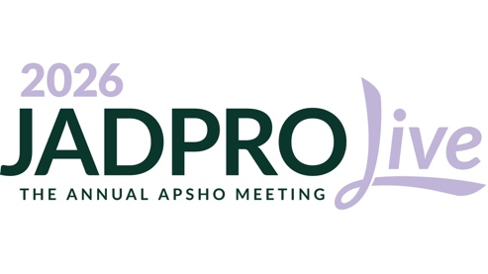
Dear [Manager],

To support [insert your facility]’s goals of [insert facility’s goals], I would like to request approval to attend JADPRO Live 2026. This educational conference will increase my knowledge base and allow me to provide a higher level of care to our hematology/oncology patients.

The conference will be held from October 15 through 18, 2026, in Minneapolis, Minnesota. This event focuses on clinical knowledge, professional development, and networking. Attending JADPRO Live provides the following benefits:
- Access to in-depth sessions and education targeted toward higher-level thinking and practical application.
- High ROI for continuing education (CE) dollars. In addition, all CE sessions will be available on-demand after the in-person event, allowing me to earn the maximum credit hours.
- Engaging interaction and networking with advanced practice peers to learn best practices from around the country.

I am looking forward to these conference sessions on [insert your sessions of interest] as they will be directly applicable to what I do each day. I’ll return to work ready to put these new skills into practice. In addition, I’ll be able to share them with colleagues to benefit the facility as a whole.

The conference will allow me to earn CE hours needed to maintain my licensure and certification, making it both an efficient use of our CE budget and time away from work.

Costs
JADPRO Live offers advanced practitioners a reasonable registration rate of [insert your applicable registration rate]. The in-person registration fee includes access to the accredited CE sessions, satellite symposia, event meals, networking and peer learning events, exhibit hall, and all on-demand content. My estimated cost for travel is $[Cost] and cost for hotel accommodations is $[Cost]. The total estimated cost to attend this conference is $[Cost].

I believe attending JADPRO Live is a great opportunity to see how we can implement positive change and best practices at our facility.

Thank you for your consideration.

Sincerely,

[INSERT NAME]

For more information on the event, visit https://jadprolive.com/

