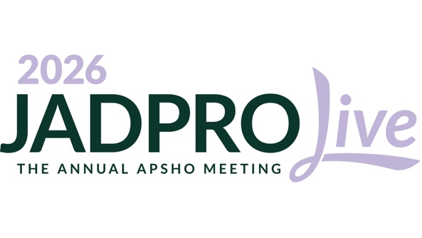
Dear [Manager],
To support [insert your facility]’s goals of [insert facility’s goals], I would like to request approval to virtually attend JADPRO Live 2026. This meeting will increase my knowledge base and allow me to provide a higher level of care to our hematology/oncology patients.
Sessions will be livestreamed from October 15 through 28, 2026, and available on demand from October 28 to December 31. There will be access to the extensive poster gallery as well. This event focuses on clinical knowledge and professional development. Attending JADPRO Live provides the following benefits:
- Access to expert-led sessions and education targeted toward higher-level thinking and practical application
- High ROI for continuing education (CE) dollars. In addition, all CE sessions will be available on-demand after the in-person event, allowing me to earn the maximum credit hours.

I am looking forward to these conference sessions on [insert your sessions of interest], as they are directly applicable to what I do each day. I’ll return to work ready to put these new skills into practice. In addition, I’ll be able to share them with colleagues to benefit the facility as a whole.
The conference will allow me to earn CE hours needed to maintain my licensure and certification, making it both an efficient use of our CE budget and time away from work.
Costs
I understand the importance of cost-effective strategies at our facility. JADPRO Live offers advanced practitioners a reasonable registration rate of [insert your applicable registration rate]. The on-demand content allows me to continue to stay up to date in our practice and maintain high standards of care. This is an investment in not only our practice but also in patient care. I believe it is a valuable opportunity to see how we can implement positive change and best practices at our facility.
Thank you for your consideration.
Sincerely,
[INSERT NAME]
For more information on the event, visit https://jadprolive.com/

